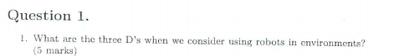

Dirty

Dull

Dangerous



○ Industry

○ Military

○ Space

Entertainment

○ Domestic

○ Medicine

○ Academia

○ Harsh Environments

○ Search and Rescue



Actuators: devices which transduce power into kinetic energy or movement



Electroactive Polymers (EAPs) are change their shape when electrically stimulated



The relative mobility of electrons within a material is known as electric conductivity.

conductors: Silver, copper, gold, iron.

 \

An open loop control system acts completely on the basis of input

l A closed loop control system considers the current output and alters it to the desired condition



• Power supply

• Actuators

• Sensors

• Control Architecture

• Environment



Voltage is the amount of potential energy available per unit charge, to move electrons through a conductor.

Voltage is the measure of specific potential energy (potential energy per unit charge) between two locations.

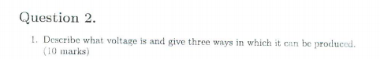

Voltage is the amount of potential energy available per unit charge, to move electrons through a conductor.

Chemical reactions: batteries

Radiant energy: solar cells

The influence of magnetism on conductors: generators



A source supplies energy to a system.

A circuit is an unbroken loop of conductive material that allows electrons to flow through continuously without beginning or end.

A load accepts energy from a system.



Sensitivity

Cross sensitivity

Error/Accuracy

Systematic/Deterministic ErrorRandom/Non-Deterministic Error



Usually no direct way to measure the robot’s position

Position must be integrated over time

Leads to inaccuracies in position (motion) estimate



Degrees of freedom, in a mechanics context, are specific, defined modes in which a mechanical device or system can move. The number of degrees of freedom is equal to the total number of independent displacements or aspects of motion. A machine may operate in two or three dimensions but have more than three degrees of freedom. The term is widely used to define the motion capabilities of robots.

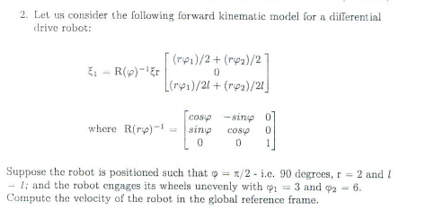.

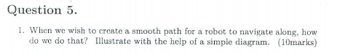

We do this by iteratively updating the waypoints in the path plan in two ways

As we move X1 in, we reduce the distance between X1 and X0 and X1 and X2

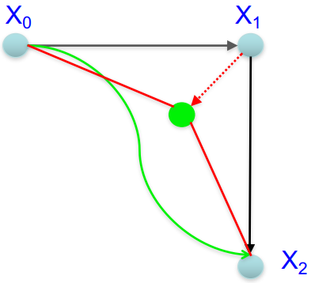



Advantages of legged locomotion:

– Adaptability & manoeuvrability over rough terrain

– Quality of ground between point contacts does not matter

– Capable of crossing chasms

– Potential to manipulate objects

Disadvantages of legged locomotion:

– Power and mechanical complexity requirements